1. Capture and analyze ARP packets using Wireshark. Inspect the ARP request and reply frames when your device attempts to find the router's MAC address.
Discuss the importance of ARP in packet forwarding.
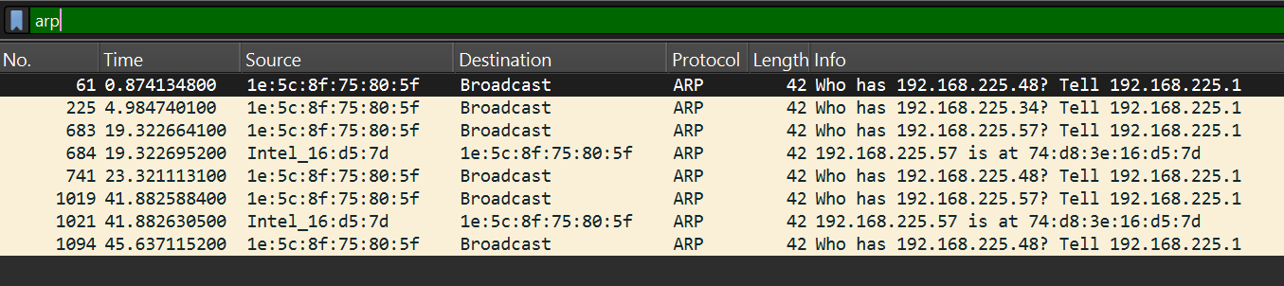
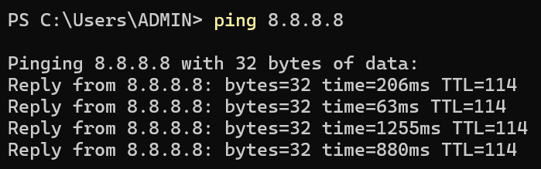
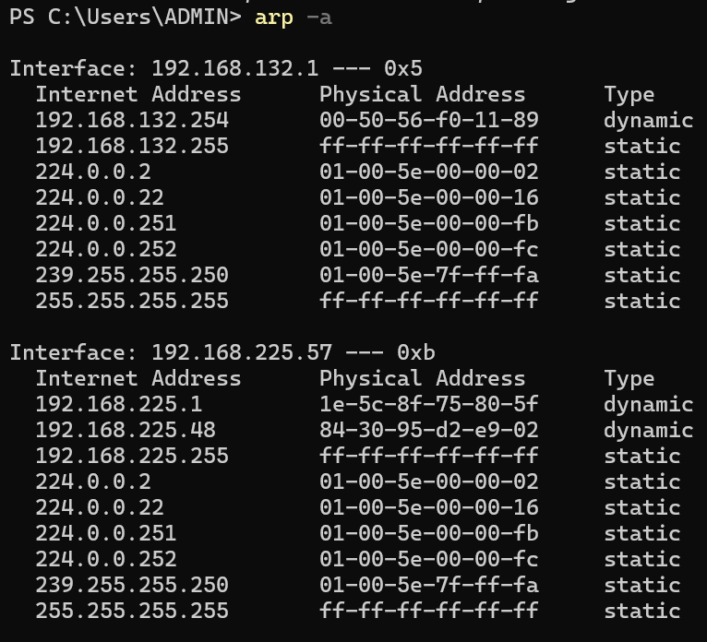The Address Resolution Protocol is an essential protocol used in local networks to map an IP address to a MAC address. Devices in a network communicate using IP addresses, but actual data transmission over Ethernet requires the physical MAC address of the destination device. When a computer wants to send data to another device such as a router, it first checks its ARP table to see if the MAC address corresponding to the destination IP address is already known. If it is not found, the device broadcasts an ARP request asking which device owns that IP address. The device with that IP address responds with an ARP reply containing its MAC address. After receiving the reply, the sender stores the mapping in its ARP cache and uses the MAC address to forward Ethernet frames. Without ARP, devices would not be able to locate each other’s hardware addresses on a local network, making communication impossible. Therefore, ARP plays a critical role in packet forwarding by enabling correct delivery of packets between devices within the same network.
2. Manually configure static routes on a router to direct packets to different subnets.Use the ip route command and verify connectivity using ping and traceroute.
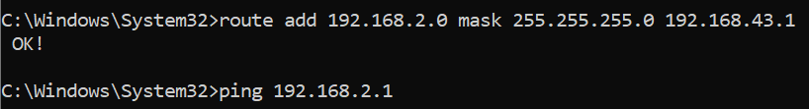
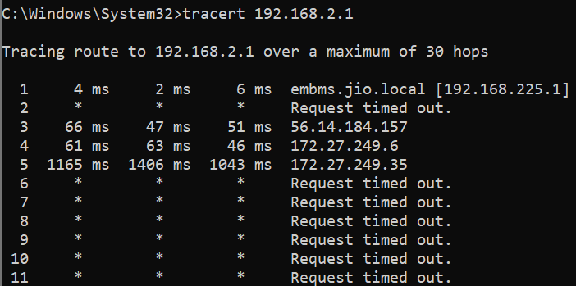A static route was manually configured using the route command to direct packets to the network 192.168.2.0 through the gateway. The routing table was verified using the route print command. Connectivity was tested using the ping command and the packet path was analyzed using traceroute. Since the destination network did not exist in the current physical network setup, the packets were forwarded to the default gateway and eventually timed out. However, the experiment demonstrates how static routing entries can be configured and verified in a system.

3) Manually configure static IPs on the client devices(like Pc or your mobile phone) and verify connectivity using ping.
A static IP address was manually configured on the client device by assigning an IP address, subnet mask, and default gateway through the network adapter settings. Unlike dynamic IP addresses that are automatically assigned by a DHCP server, static IP addresses remain fixed. After configuring the static IP address, the network configuration was verified using the ipconfig command. Connectivity with the router was then tested using the ping command. Successful ping replies confirmed that the device was correctly configured with the static IP address and was able to communicate with other devices in the network.
3. Given a network address of 10.0.0.0/24, divide it into 4 equal subnets.Calculate the new subnet mask.Determine the valid host range for each subnet.Assign IP addresses to devices in Packet Tracer and verify connectivity.

The 4 Subnets
Subnet |  | Network Address |  | Host Range |  | Broadcast
Subnet 1 |  | 10.0.0.0/26 |  | 10.0.0.1 – 10.0.0.62 |  | 10.0.0.63
Subnet 2 |  | 10.0.0.64/26 |  | 10.0.0.65 – 10.0.0.126 |  | 10.0.0.127
Subnet 3 |  | 10.0.0.128/26 |  | 10.0.0.129 – 10.0.0.190 |  | 10.0.0.191
Subnet 4 |  | 10.0.0.192/26 |  | 10.0.0.193 – 10.0.0.254 |  | 10.0.0.255

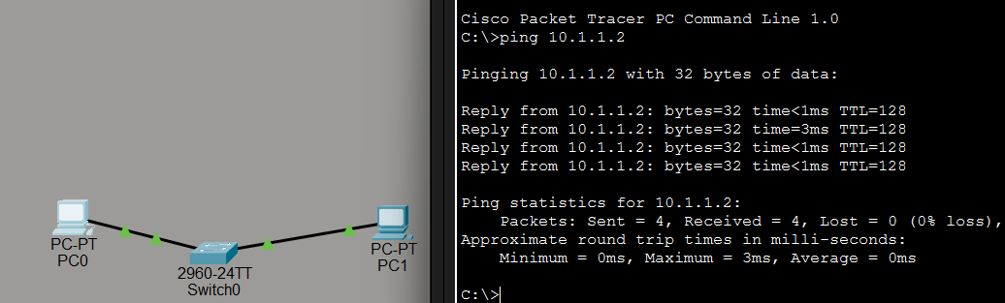
4. You are given three IP addresses: 192.168.10.5, 172.20.15.1, and 8.8.8.8.Identify the class of each IP address.Determine if it is private or public.Explain how NAT would handle a private IP when accessing the internet.
IP Address |  | Class | Private/Public
192.168.10.5 |  | Class C | Private
172.20.15.1 |  | Class B | Private
8.8.8.8 |  | Class A | Public
Private IP addresses cannot access the internet directly because they are only valid inside local networks. To allow these devices to communicate with the internet, routers use NAT.
When a device with a private IP address sends a request to the internet, the router replaces the private IP address with its own public IP address. The router keeps a translation table that records which internal device made the request. When the response from the internet returns, the router looks at this table and forwards the response back to the correct private IP device. This process allows many private devices in a local network to share a single public IP address while accessing the internet securely.

5. In Cisco Packet Tracer, configure NAT on a router to allow internal devices

(192.168.1.x) to access the internet.

Test connectivity by pinging an external public IP.

Capture the traffic in Wireshark and analyze the source IP before and after NAT translation.
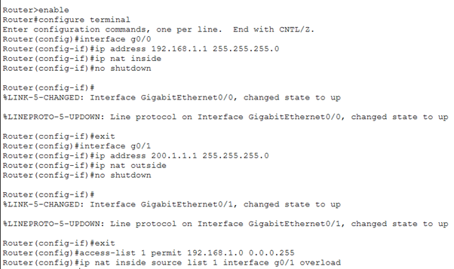
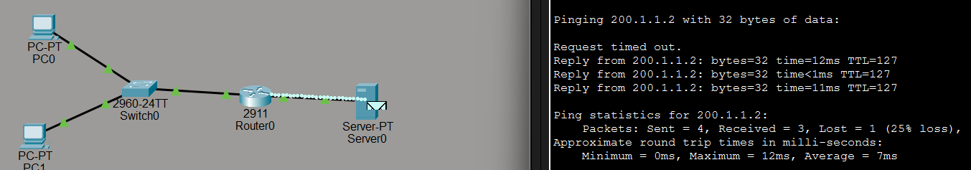
NAT was configured on a router in Cisco Packet Tracer to allow devices in the internal network to access external networks. The router’s inside interface was assigned to the private network and the outside interface was connected to the public network. NAT overload was configured so multiple internal devices could share a single public IP address. Connectivity was tested using the ping command to reach an external IP address. Packet capture was performed using Wireshark to analyze the traffic. The captured packets showed that the private source IP address was translated into the router’s public IP address when the packet left the internal network, demonstrating how NAT enables private networks to access the internet.

